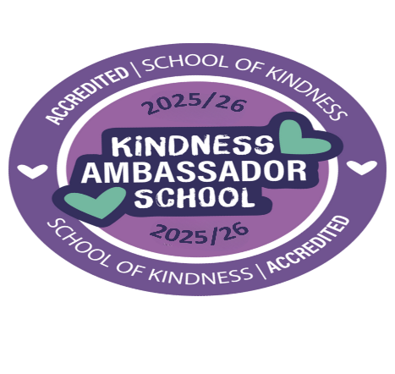

APPLICATION FORM
Name: Class:

A Kindness Ambassador helps make our school a happy, caring and friendly place. We are looking for children who enjoy helping others and spreading kindness.

Why would you like to be a Kindness Ambassador?

Give an example of a time when you were kind to someone.

If I become a Kindness Ambassador, I would…

Please return your application form to your class teacher by Monday 21 September

